**WORD CLOUD & SENTIMENTAL ANALYSIS**

**Business Problem** = ﻿﻿﻿﻿﻿﻿﻿﻿Extracting reviews of Dark web-series from Snapdeal and performing sentimental analysis.

* **Name of Product : -** Dark.(Netflix)
* **Website : -** imdb.com
* **Review URL : -** ﻿https://www.imdb.com/title/tt5753856/reviews?ref_=tt_ql_3
* **Review Extracted : -** Top25

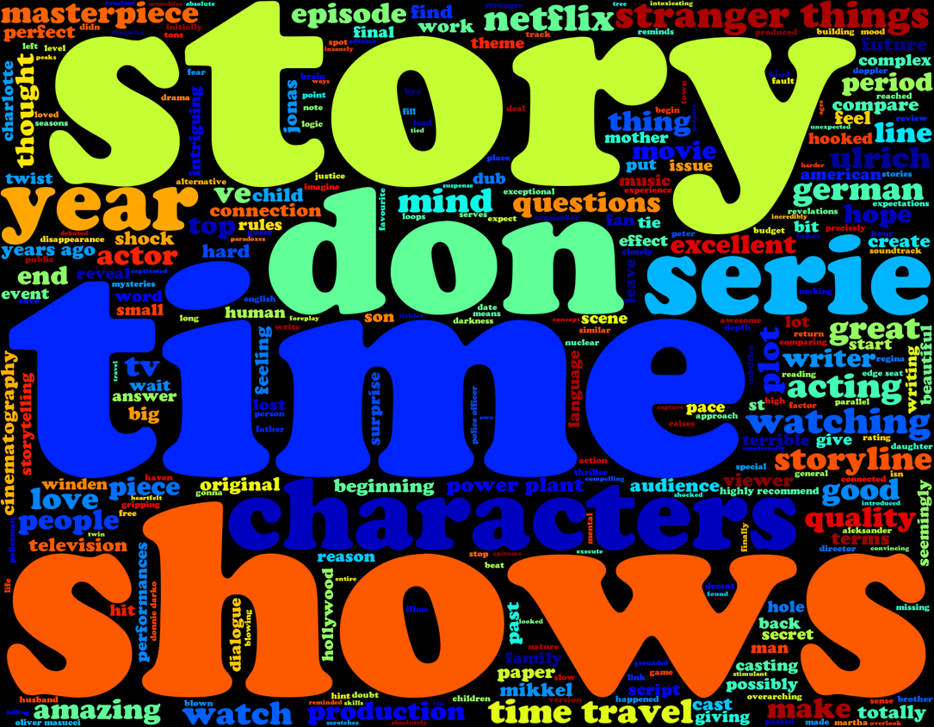

**Word Cloud** =

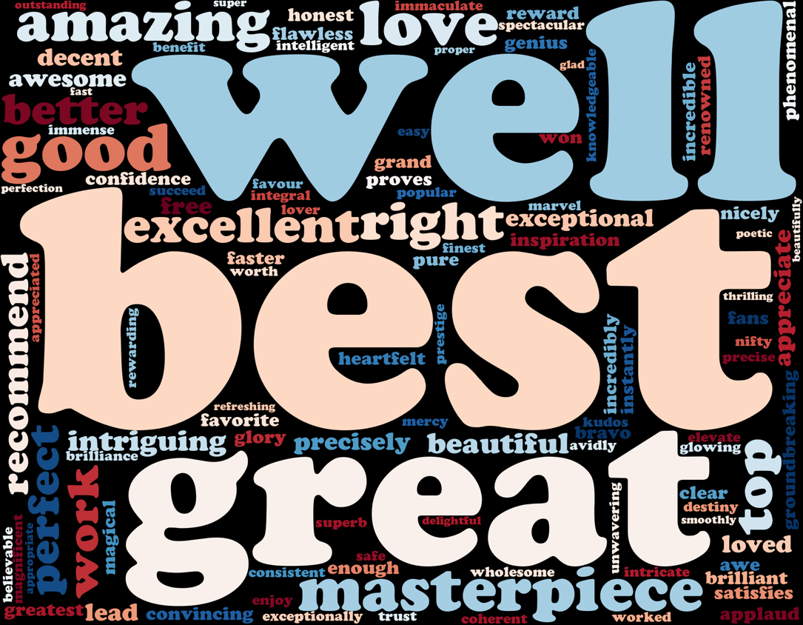**Positive Sentimental Analysis =**

**Negative Sentimental Analysis =**

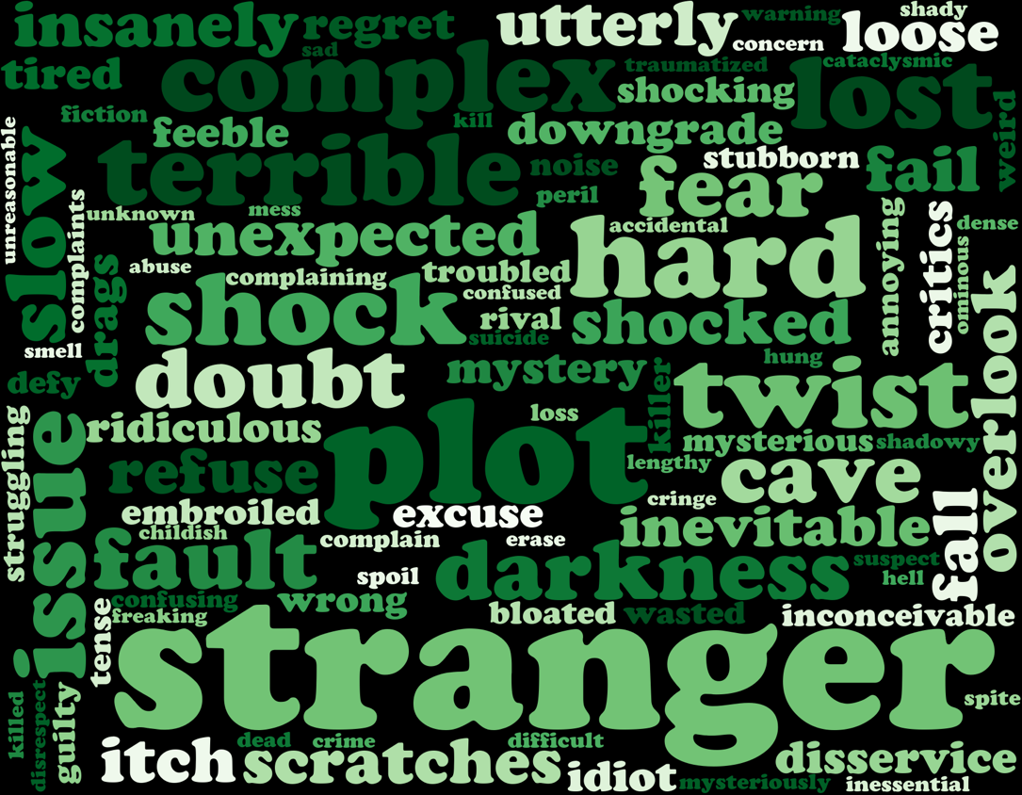

**Python code file**: - [IMDb Word Cloud (Dark).py](https://github.com/nilaydeshmukh0/Text-Mining-and-Sentiment-Analysis/blob/master/IMDb%20Product%20Analysis/IMDb%20Word%20Cloud%20(Dark).py)